CAPSTONE PROJECT - SAKILA DVD RENTAL STORE

**SREE HARsHITHA THIKKIREDDI**

OVERVIEW OF THE PROJECT

The Sakila DVD Rental Store Database is a comprehensive dataset that offers valuable insights into the operations of a fictitious DVD rental business. This database, designed for analysis, provides a wealth of information that can be leveraged for business optimization and decision-making.

**Rich Data Source:** The database includes a wide range of tables representing different aspects of the rental store's operations, such as films, customers, staff, payments, and rentals. This rich dataset forms the foundation for in-depth analysis.

**Objective Understanding:** The primary objective of analysing this database is to gain a deep and objective understanding of the rental business. Through data exploration, we aim to uncover hidden trends, customer behaviours, and operational insights.

**Valuable Insights:** The analysis of this database can yield valuable insights, including but not limited to:

* Identifying popular films and categories.
* Analysing customer rental patterns and preferences.
* Evaluating staff performance and customer satisfaction.
* Discovering payment trends and late payment behaviours.
* Optimizing inventory management and rental strategies.

**Data-Driven Decision-Making:** The ultimate goal is to empower data-driven decision-making. By leveraging the insights gained from this database, businesses can make informed choices regarding inventory, customer service, marketing, and overall operational improvements.

**Enhancing Customer Experience:** Through this analysis, we aim to enhance the customer experience by tailoring services and offerings to customer preferences and behaviours. This, in turn, can lead to increased customer satisfaction and loyalty.

In summary, the Sakila DVD Rental Store Database is a valuable resource for businesses seeking to understand their operations better and make data-driven improvements. By exploring the data and extracting meaningful insights, businesses can optimize various aspects of their rental services, leading to enhanced profitability and customer satisfaction.

PROJECT PLAN

**1. Data Retrieval from GitHub:**

Begin by sourcing the relevant dataset from a designated GitHub repository. This dataset contains essential information about the Sakila DVD Rental Store's operations, encompassing rental records, customer details, staff data, and more.

**2. Data Refinement and Enrichment:**

If required, perform data refinement procedures to ensure data quality and consistency. Additionally, consider enriching the dataset with additional attributes to expand the analysis potential. This could involve calculating new metrics or categorizing customers for segmentation.

**3. Integration with Analytical Tools:**

Establish seamless connections between the Sakila dataset and various analytical tools, including Power BI, Excel, and SQL Workbench. This integration will enable efficient data processing, exploration, and visualization.

**4. Problem Solving with Power BI:**

Leverage Power BI to address specific problem statements related to the Sakila DVD Rental Store. Utilize Power BI's robust features for data visualization, exploration, and analysis to derive actionable insights and solutions.

**5. Exploratory Data Analysis (EDA):**

Conduct exploratory data analysis using Excel or SQL Workbench, depending on the analysis complexity. Extract meaningful patterns, relationships, and trends from the dataset to inform decision-making. This step will provide a deeper understanding of the Sakila rental business.

**6. Creation of Informative PowerPoint Presentation:**

Develop a comprehensive PowerPoint presentation that encapsulates the project's objectives, methodologies, problem statement solutions, and key visualizations. Each problem statement should have a dedicated section, presenting pertinent conclusions and actionable insights.

**7. Thorough Project Documentation:**

Create a detailed report that meticulously documents the entire project lifecycle. Include sections on data acquisition, refinement, problem statement formulation, tools integration, Power BI solutions, EDA insights, and PowerPoint visualizations. This documentation ensures transparency and facilitates knowledge sharing.

OBJECTIVE OF THE PROJECT

The Sakila DVD Rental Store Database is a comprehensive dataset that encompasses rental records, customer information, staff data, and more. The objective of this project is to conduct a thorough analysis of the Sakila database to uncover valuable insights, identify opportunities for optimization, and enhance decision-making processes. The project will involve the following key tasks:

**Comprehensive Data Analysis:** Perform a comprehensive analysis of rental data, encompassing factors such as film popularity, customer preferences, staff performance, and rental trends.

**Customer Segmentation:** Group customers based on their rental behaviours and characteristics to understand distinct customer segments.

**Staff Performance Evaluation:** Evaluate staff performance and customer satisfaction to enhance service quality and efficiency.

**Inventory Management:** Optimize inventory management by predicting demand and supply for different films and suppliers.

**Payment Trends:** Analyse payment trends, late payments, and other financial aspects to improve payment processes.

**Enhanced Reporting:** Develop meaningful visualizations and presentations to communicate insights effectively.

The success of the project will be measured based on the following criteria:

* **Analysis Quality:** The quality of the analysis conducted on the Sakila database.
* **Insight Relevance:** The relevance and applicability of the insights generated.
* **Recommendation Impact:** The impact of recommendations made to optimize rental operations.

This project holds significance as it has the potential to improve the overall efficiency, customer experience, and profitability of the Sakila DVD Rental Store. By identifying patterns and opportunities within the dataset, the project aims to empower data-driven decision-making and enhance the store's competitive advantage in the market.

SIGNIFICANCE OF THE PROJECT

The Sakila DVD Rental Store Database is not only a valuable resource for business analysis but also a platform for showcasing data analysis skills and techniques in solving real-world challenges. This dataset provides opportunities to create impactful projects and reports, offering insights that can drive business intelligence and informed decision-making. Some potential projects and reports based on the Sakila database include:

**Customer Segmentation:** Analysing customer rental behaviours and preferences to identify distinct segments and tailor marketing strategies.

**Inventory Optimization:** Optimizing inventory management and supply chain operations for different films and suppliers to reduce costs and improve resource allocation.

**Employee Performance Assessment**: Evaluating employee performance and satisfaction across various roles and regions to enhance workforce efficiency.

**Payment and Late Fee Analysis:** Analysing payment trends and late fees to streamline payment processes and maximize revenue collection.

**Comparative Analysis**: Conducting comparative analyses between the Sakila database and other relevant datasets or real-world data sources to gain broader industry insights.

**Real-World Impact:**

**Enhanced Customer Experience**: By understanding customer preferences and rental behaviours, businesses can tailor their services to enhance the customer experience, leading to higher satisfaction and loyalty.

**Operational Efficiency:** Optimizing inventory and supply chain operations can result in cost savings, reduced wastage, and improved resource allocation.

**Data-Driven Decision-Making:** The analysis of the Sakila database empowers data-driven decision-making across various aspects of the DVD rental business, from marketing to inventory management.

**Competitive Advantage:** Leveraging insights from this dataset can provide a competitive edge by responding effectively to market dynamics and customer needs.

In conclusion, the Sakila DVD Rental Store Database offers a platform to harness the power of data analysis and visualization. By applying analytical skills to real-world challenges, organizations can make informed decisions, streamline operations, and ultimately achieve improved performance and competitiveness in the DVD rental industry.

DATA DICTIONARY

**Table: Actor**

|  |  |
| --- | --- |
| actor_id | Unique identifier for each actor. |
| first_name | First name of the actor. |
| last_name | Last name of the actor. |
| last_update | Date of the last update. |

**Table: Address**

|  |  |
| --- | --- |
| address_id | Unique identifier for each address. |
| address | Street address. |
| address2 | Additional address information (blank). |
| district | District or region. |
| city_id | Foreign key referencing the city_id in the city table. |
| postal_code | Postal code. |
| phone | Phone number. |
| location | Location of the address |
| last_update | Date of the last update. |

**Table: Category**

|  |  |
| --- | --- |
| category_id | Unique identifier for each category. |
| name | Name of the category. |
| last_update | Date of the last update. |

**Table: City**

|  |  |
| --- | --- |
| city_id | Unique identifier for each city. |
| city | City name. |
| country_id | Foreign key referencing the country_id in the Country table. |
| last_update | Date of the last update. |

**Table: Country**

|  |  |
| --- | --- |
| country_id | Unique identifier for each country. |
| country | Country name. |
| last_update | Date of the last update. |

**Table: Customer**

|  |  |
| --- | --- |
| customer_id | Unique identifier for each customer. |
| store_id | Foreign key referencing the store_id in the Store table. |
| first_name | First name of the customer. |
| last_name | Last name of the customer. |
| email | Email address of the customer. |
| address_id | Foreign key referencing the address_id in the Address table. |
| active | Boolean value indicating whether the customer is active. |
| create_date | Date when the customer record was created. |
| last_update | Date of the last update to the customer record. |

**Table: Film**

|  |  |
| --- | --- |
| film_id | Unique identifier for each film. |
| title | Title of the film. |
| description | Description of the film. |
| release_year | Year when the film was released. |
| language_id | Foreign key referencing the language_id in the Language table. |
| original_language_id | Foreign key referencing the language_id in the Language table for the original language of the film. |
| rental_duration | Rental duration of the film. |
| rental_rate | Rental rate of the film. |
| length | Length of the film in minutes. |
| replacement_cost | Replacement cost of the film. |
| rating | Rating of the film. |
| special_features | Special features of the film. |
| last_update | Date of the last update to the film record. |

**Table: Film_Actor**

|  |  |
| --- | --- |
| actor_id | Foreign key referencing the actor_id in the Actor table. |
| film_id | Foreign key referencing the film_id in the Film table. |
| last_update | Date of the last update. |

**Table: Film_Category**

|  |  |
| --- | --- |
| film_id | Foreign key referencing the film_id in the Film table. |
| category_id | Foreign key referencing the category_id in the Category table. |
| last_update | Date of the last update. |

**Table: Film_Text**

|  |  |
| --- | --- |
| film_id | Unique identifier for each film. |
| title | Title of the film. |
| description | Description of the film. |

**Table: Inventory**

|  |  |
| --- | --- |
| inventory_id | Unique identifier for each inventory item. |
| film_id | Foreign key referencing the film_id in the Film table. |
| store_id | Foreign key referencing the store_id in the Store table. |
| last_update | Date of the last update. |

**Table: Language**

|  |  |
| --- | --- |
| language_id | Unique identifier for each language. |
| name | Name of the language. |
| last_update | Date of the last update. |

**Table: Payment**

|  |  |
| --- | --- |
| payment_id | Unique identifier for each payment. |
| customer_id | Foreign key referencing the customer_id field in the Customer table. |
| staff_id | Foreign key referencing the staff_id field in the Staff table. |
| rental_id | Foreign key referencing the rental_id field in the Rental table. |
| amount | Payment amount. |
| payment_date | Date when the payment was made. |
| last_update | Date of the last update. |

**Table: Rental**

|  |  |
| --- | --- |
| rental_id | Unique identifier for each rental. |
| rental_date | Date when the rental was made. |
| inventory_id | Foreign key referencing the inventory_id field in the Inventory table. |
| customer_id | Foreign key referencing the customer_id field in the Customer table. |
| return_date | Date when the rental was returned. |
| staff_id | Foreign key referencing the staff_id field in the Staff table. |
| last_update | Date of the last update to the rental record. |

**Table: Staff**

|  |  |
| --- | --- |
| staff_id | Unique identifier for each staff member. |
| first_name | First name of the staff member. |
| last_name | Last name of the staff member. |
| address_id | Foreign key referencing the address_id field in the Address table. |
| email | Email address of the staff member. |
| store_id | Foreign key referencing the store_id field in the Store table. |
| active | Boolean value indicating whether the staff member is active. |
| username | Username for staff login. |
| password | Password for staff login. |
| last_update | Date of the last update to the staff record. |

**Table: Store**

|  |  |
| --- | --- |
| store_id | Unique identifier for each store. |
| manager_staff_id | Foreign key referencing the staff_id field in the Staff table for the store manager. |
| address_id | Foreign key referencing the address_id field in the Address table for the store location. |
| last_update | Date of the last update to the store record. |

ER DIAGRAM

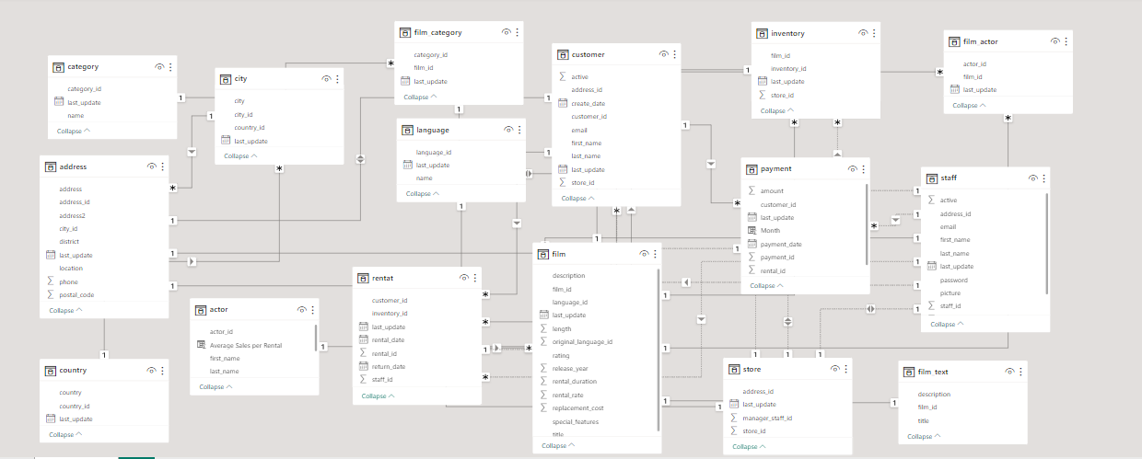

power bi - PROBLEM STATEMENTS

**PS-1: How does the sales revenue vary by month?**

**Objective/Need for Analysis:**

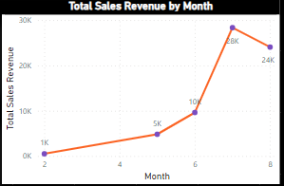The objective of this sales analysis is to understand how sales revenue varies by month for the Sakila DVD Rental Store database (2005-2006). This analysis is essential for identifying revenue trends over time, which can help in making informed business decisions, optimizing inventory, and planning marketing strategies.

**Charts and Table Explanation:**

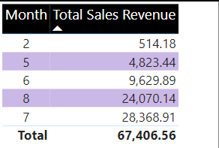**1. Line Chart:** The line chart visualizes the variation in total revenue across different months. The months are represented numerically, where '2' corresponds to February, '5' to May, '6' to June, '7' to July, and '8' to August. The chart clearly shows that July (Month 7) has the highest total revenue, followed by August (Month 8), June (Month 6), May (Month 5), and February (Month 2). This chart provides a quick overview of revenue distribution over time.

**2. Table:** The table presents detailed information, including the revenue for each month and the total number of customers. It reinforces the insights from the line chart, allowing for precise data examination.

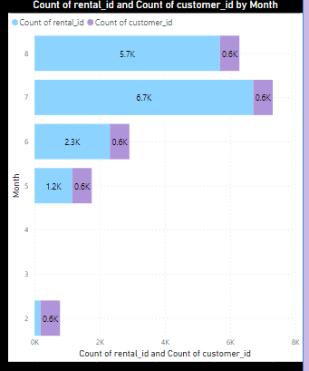**3. Stacked Bar Chart:** The stacked bar chart displays two important metrics per month: the count of rental IDs and the count of customers. It visually illustrates the volume of rentals and the number of customers in each month. Month 7 (July) has the highest count of rental IDs, indicating a high volume of rentals during that period.

**Observations and Findings:**

**Highest Revenue Month:** July (Month 7) stands out with the highest total revenue of 28,368.91, suggesting that it is a peak sales month for the Sakila DVD Rental Store.

**Rental Volume:** The stacked bar chart highlights that July also has the highest count of rental IDs, indicating a significant number of transactions during that month.

**Customer Base:** The analysis reveals that there are a total of 599 customers, and this customer base is contributing to the sales revenue across the months.

**Implications:**

**1. Peak Sales Month:** Recognizing July as the peak sales month can help in planning promotions, discounts, and marketing campaigns to capitalize on the high customer activity during that period.

**2. Customer Retention:** Understanding the number of customers per month can aid in customer retention strategies. Efforts can be directed towards retaining and engaging customers, especially during months with lower customer counts.

In summary, this sales analysis provides valuable insights into revenue variations by month, offering actionable information for business strategies and decision-making in the Sakila DVD Rental Store.

**PS-2: What is the distribution of sales by payment method?**

NOTE: Payment Analysis Limitation: The dataset lacks explicit payment method information, and the payment_id column contains unique numerical values, preventing direct attribution of payment methods to transactions.

**Objective or Need for Analysis:**

The aim of the Payment Analysis is to gain insights into sales distribution and patterns over a specified period in the Sakila DVD Rental Store Database (2005-2006). This analysis, provides valuable insights into payment patterns and variations over time.

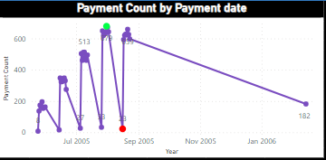**Chart Explanation:**

The Line Chart in the Payment Analysis Dashboard visualizes the variation in payment counts by payment date, starting from July 2005 and spanning to January 2006. The chart's x-axis is formatted to display the payment date with granularity at the day, month, quarter, and year levels. **(**Payment Count = COUNT(Payment[payment_date])**)**.

**Green Dot Marker:** The chart highlights the highest payment count, which occurred on July 31, 2005, in Quarter 3, with a remarkable 679 payments. This green dot marker signifies a peak in sales activity for that specific date.

**Red Dot Marker:** Conversely, the lowest payment count was observed on August 16, 2005, in Quarter 3, with only 23 payments. This is indicated by a red dot marker, highlighting a day with notably lower sales.

**Observations and Findings:**

**Sales Variations:** The line chart clearly illustrates fluctuations in payment counts over the specified period. There are noticeable peaks and valleys, suggesting that sales activity was not uniform but rather subject to variations.

**Seasonal Patterns:** While not explicitly visible in the chart, patterns may emerge over a more extended time frame. Further analysis could reveal if there are seasonal trends, such as increased sales during specific months or quarters.

**Implications:**

**Inventory Management:** Understanding payment variations can help in optimizing inventory management. Higher sales periods may require increased stock levels, while lower sales periods may allow for reduced inventory.

In conclusion, the Payment Analysis based on payment count in the Sakila DVD Rental Store Database provides valuable insights into sales distribution and patterns over the specified time frame. While the analysis does not directly address payment methods, it serves as a useful proxy for understanding sales dynamics, which can inform strategic decisions related to inventory and marketing.

**PS-3: Which customer segments generate the highest sales?**

**Objective/Need for Analysis:**

The objective of this analysis is to identify the customer segments that generate the highest sales for the Sakila DVD Rental Store. This involves understanding the relationship between customer location (country) and their rental behaviour, including the count of customers, average rental amounts, and payment frequency.

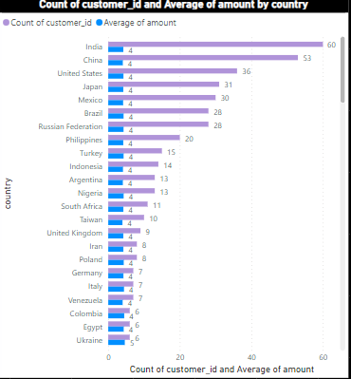**Location Analysis - Customer Count vs. Average Amount (Clustered Bar Chart):**

**Chart:** The clustered bar chart visually presents the count of customers and the average rental amount by country.

**Explanation:** Sorting the axis by customer count reveals that India, China, the US, Japan, and Mexico have the highest customer bases. Sorting by average amount shows that Nepal and Turkmenistan have the highest average rental amounts, though with a significantly lower customer count.

**Observations:** India, China, the US, Japan, and Mexico have substantial customer bases and moderately high average rental amounts, making them crucial for overall sales.

**Findings:** Countries with a large customer base, such as India and China, contribute significantly to overall sales, while countries with higher average rental amounts, like Nepal and Turkmenistan, have potential for increased revenue per customer.

**Implications:** This analysis suggests that efforts can be made to attract more customers from countries like Nepal and Turkmenistan to boost average rental amounts. Additionally, strategies to retain and engage customers in countries like India and China can result in increased overall sales.

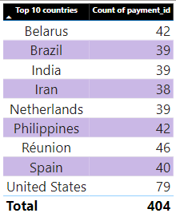**Top 10 Countries by Payment Count (Table):**

**Table:** Displays the top 10 countries **(**Top N filter**)** with the highest count of payment transactions.

**Explanation:** United States leads with 79 payment transactions, followed by Iran with 38, and a total of 404 payments across these top 10 countries.

**Observations:** The United States has the highest payment count, indicating a high frequency of transactions.

**Findings:** High payment counts in the United States suggest a strong revenue generation potential.

**Implications:** Focusing on customer engagement and retention in countries with high payment counts, like the United States, can lead to sustained revenue growth. Additionally, marketing efforts in countries like Iran may help increase payment counts and sales.

In conclusion, this analysis provides insights into customer segmentation and location-based sales performance. It highlights the importance of both customer count and average rental amounts in different countries, guiding strategies for revenue enhancement and customer engagement.

**PS-4: What is the distribution of films by rental duration?**

**Objective/Need for Analysis:**

The objective of this analysis is to understand the distribution of films within the Sakila DVD Rental Store Database based on their rental_duration. This information is crucial for optimizing inventory management, catering to customer preferences, and enhancing rental strategies.

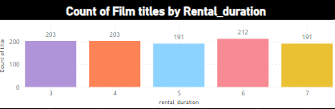**Charts and Explanation:**

A clustered column chart has been used to visualize the distribution of film titles by rental_duration. Rental durations are categorized as 3, 4, 5, 6, and 7 days.

**Observation and Findings:**

**1. Most Common Rental Duration:** The analysis reveals that films with a rental duration of 6 days are the most common, with 212 films falling into this category. This suggests that a significant portion of the film inventory is optimized for a 6-day rental period.

**2. Variation in Rental Durations:** While 6-day rentals dominate, it's notable that films with rental durations of 3, 4, 5, and 7 days are also well-represented, each with 203, 203, 191, and 191 films, respectively. This indicates a diverse inventory to cater to different customer preferences.

**3. Total Number of Films:** The analysis covers a total of 1000 films, showcasing a substantial variety of choices for customers.

**Implications:**

**1. Inventory Management:** Understanding the distribution of rental durations can aid in optimizing inventory levels. For example, since 6-day rentals are the most common, ensuring an adequate stock of films with this duration can prevent stockouts.

**2. Customer Preferences:** The variation in rental durations suggests that customers have different preferences. Tailoring marketing and recommendations based on these preferences can enhance the customer experience.

**3. Pricing and Promotions:** The findings can guide pricing strategies and promotional campaigns. Offering discounts or promotions for films with less common rental durations can incentivize rentals and balance inventory utilization.

This analysis provides valuable insights into the rental duration preferences of customers, which can inform strategic decisions related to inventory management, customer engagement, and pricing strategies within the Sakila DVD Rental Store.

**PS-5: How does the inventory vary by film rating?**

**Objective/Need for Analysis:**

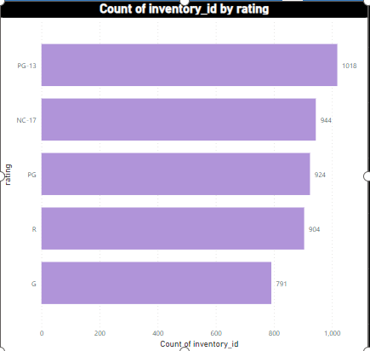The objective of this analysis is to understand how inventory varies by film rating in the Sakila DVD Rental Store Database (2005-2006). This insight will help in optimizing inventory management, ensuring that the store stocks an appropriate number of DVDs for each film rating category. The analysis also provides valuable information for strategic decision-making and resource allocation.

**Charts and Matrix Explanation:**

**1. Clustered Bar Chart:** The clustered bar chart visually represents the distribution of inventory_id by film rating. Each bar represents a film rating category (PG, PG-13, R, G, NC-17), and the height of the bar represents the count of inventory items within that rating. This chart helps in comparing inventory levels across different film ratings at a glance.

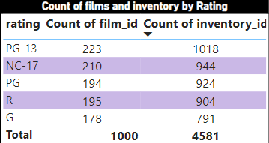**2. Matrix:** The matrix displays the count of film_id and inventory_id by film rating. It provides a detailed breakdown of how many films belong to each rating category and the corresponding inventory count. This matrix offers a more granular view of the data, allowing for precise analysis.

**Observations and Findings:**

* The analysis reveals that the film rating "PG-13" has the highest inventory count with 1,018 items, indicating a relatively higher stock of DVDs in this category.
* The "NC-17" rating follows closely with 944 inventory items, suggesting a substantial presence in the store.
* "PG" and "R" rated films also have significant inventory counts with 924 and 904 items, respectively.
* The "G" rating category has the lowest inventory count among the listed ratings, with 791 items.

**Implications:**

**1. Inventory Optimization:** The data indicates that there is a varying demand for DVDs based on film ratings. To optimize inventory management, it's essential to align stock levels with customer preferences. Consider adjusting the inventory levels for each rating category to ensure a balanced supply that meets customer demand.

**2. Marketing and Promotion:** The higher inventory in certain rating categories, such as "PG-13" and "NC-17," may suggest stronger customer interest. Utilize this information for targeted marketing and promotional activities to boost rentals in these categories.

This analysis provides actionable insights into inventory management and film preferences, allowing the Sakila DVD Rental Store to enhance customer satisfaction, reduce carrying costs, and drive business growth.

**PS-6: What is the breakdown of film categories in the inventory?**

**Objective/Need for Analysis:**

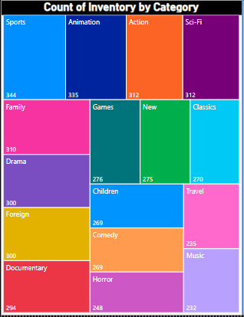The objective of this analysis is to gain a comprehensive understanding of the breakdown of film categories within the inventory of the Sakila DVD Rental Store Database. By visualizing the distribution of inventory items across different film categories, we aim to identify patterns, assess category popularity, and make data-driven decisions regarding inventory management.

**Charts Explanation:**

**Treemap Visualization:** The treemap chart provides a clear representation of the distribution of inventory items by film category. Each rectangle within the treemap represents a film category, and the size of the rectangle corresponds to the number of inventory items in that category. Categories are color-coded for easy identification.

**Observations and Findings:**

**Category Popularity:** Among the 16 film categories, the Sports category has the highest inventory count with 344 items, followed closely by Animation (335), Action, and Sci-Fi (both with 312). These categories appear to be popular among customers.

**Inventory Spread:** While Sports and Animation have high inventory counts, other categories like Children and Comedy have relatively lower inventory counts (269). Horror, Travel, and Music also fall on the lower end with 248, 235, and 232 items, respectively.

**Implications:**

**1. Inventory Management Optimization:** The analysis highlights the varying popularity of film categories. To optimize inventory management, the store can consider adjusting procurement and restocking strategies. For instance, for highly popular categories like Sports and Animation, ensuring a consistent supply is crucial to meet customer demand. On the other hand, for less popular categories like Children and Comedy, inventory levels can be adjusted accordingly to minimize carrying costs.

**2. Customer Engagement:** Understanding which film categories are most popular can guide marketing efforts and promotions. The store can use this information to tailor marketing campaigns, special offers, or recommendations to engage customers and drive rentals in specific categories.

This analysis provides valuable insights into the distribution of film categories in the inventory, offering actionable recommendations for inventory management and customer engagement strategies.

**PS-7: What is the distribution of staff by employment duration?**

Note: In the absence of detailed information about staff and employment duration, the analysis in this section is conducted based on available data. The distribution of staff by employment duration is not directly available in the dataset. Therefore, the following analysis focuses on rental and payment data associated with staff.

**Objective for Staff Analysis:**

The objective of this analysis is to understand and visualize key aspects of staff performance and rental-related data. We aim to gain insights into rental distribution by staff, identify top-performing customers, and observe trends in rental payments over time.

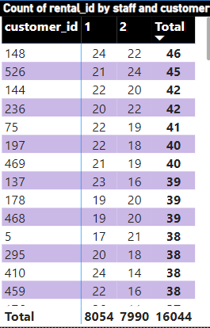**Matrix and Area Chart Explanation:**

**1. Matrix:**

* The matrix visualizes the distribution of rental transactions by staff (Staff_id 1 and Staff_id 2) and customers.
* Top 5 customers for each staff member based on total rental transactions are identified. Customer_ids 148, 526, 144, 236, and 75 are the top customers.
* The matrix helps us understand the rental engagement of each staff member with the top customers.

**2. Area Chart:**

* The area chart illustrates the total rental payment amount generated by the staff over time, segmented by day, month, quarter, and year.
* 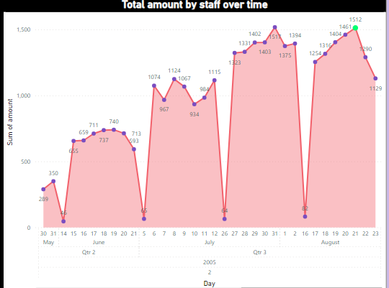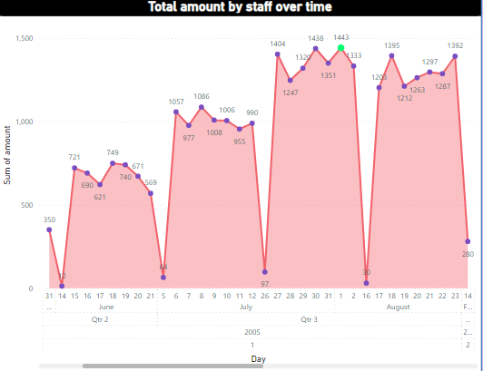In 2005, Quarter 3, August 1st recorded the highest rental payment amount for Staff_id 1 with 1442.55. For Staff_id 2, the highest amount was recorded on August 21st in Quarter 3, 2005, with 1512.49. Both are indicated by a green marker in the chart.
* This chart enables us to identify peak periods and trends in rental payments.

**Observation and Findings:**

* Staff_id 1 and Staff_id 2 both have top-performing customers, with Customer_ids 148, 526, 144, 236, and 75 being the most frequent renters.
* Rental payment amounts show fluctuations over time, with peak amounts occurring in specific quarters and months.
* Staff_id 2 generated slightly higher rental payment amounts than Staff_id, as indicated by the area chart.

**Implications:**

**1. Customer Engagement:** The identification of top-performing customers allows staff management to focus on retaining and providing excellent service to these valuable customers, potentially leading to increased customer loyalty and revenue.

**2. Payment Trends:** Monitoring payment trends over time can help in optimizing staffing and resource allocation during peak rental periods, ensuring efficient operations and customer satisfaction.

This analysis provides valuable insights into staff performance, customer engagement, and payment trends, offering opportunities for staff management and resource allocation optimization.

**PS-8: How does the store performance vary by location?**

**Objective/Need for Analysis:**

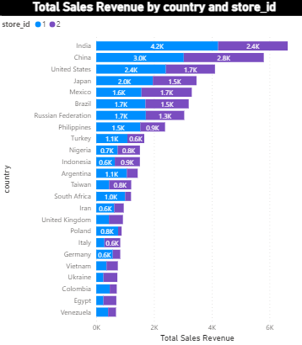The objective of the Store Performance Analysis is to evaluate how the performance of two stores (Store 1 and Store 2) varies across different geographic locations. This analysis is essential to identify regions or countries where the stores excel in generating sales revenue, assess customer distribution, and understand if there are areas that require improvement. The analysis leverages Power BI visualizations, including a Stacked Bar Chart, a Map, and a Matrix, to derive insights.

**Explanation of Visualizations:**

**1. Stacked Bar Chart:** This chart visually represents the total sales revenue generated by both Store 1 and Store 2 across different countries. It reveals that countries such as India, China, the United States, Japan, and Mexico contribute significantly to the stores' sales revenue, with India leading the way. The chart effectively illustrates the sales performance disparities between stores and countries.

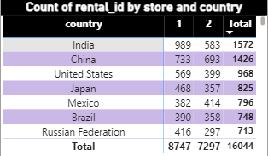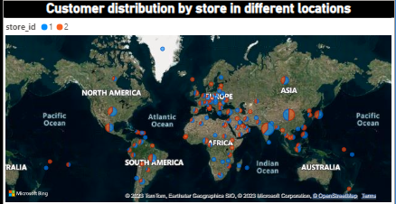**2. Map:** The map visualization displays the distribution of customers across various locations, highlighting the store's presence in different regions. It shows that India has the highest concentration of customers for both stores, indicating a robust customer base in this location.

**3. Matrix:** The matrix provides a tabular view of the rental count, showcasing how many rentals have been made in each country for each store. India stands out again as the top-performing country in terms of rental count.

**Observations and Findings:**

**High Sales Revenue in Key Countries:** The Stacked Bar Chart indicates that India, China, the United States, Japan, and Mexico are the primary revenue contributors for both stores. These countries exhibit substantial sales revenue, making them key markets for the stores.

**Customer Concentration in India**: The Map visualization underscores the significant customer distribution in India for both stores, suggesting that India plays a pivotal role in the stores' overall performance.

**Rental Count and Revenue Correlation**: While India leads in both rental count and revenue generation, it's important to note that rental count alone doesn't always correlate directly with revenue. This suggests that factors such as average transaction value or pricing strategies might vary between countries.

**Implications:**

**1. Targeted Marketing and Expansion:** Given the high customer concentration in India, there is an opportunity for the stores to implement targeted marketing strategies to further tap into this market. Additionally, considering expansion efforts or strengthening their presence in key revenue-generating countries like China, the United States, and Japan could be beneficial.

**2. Pricing and Revenue Optimization:** Understanding the differences in rental count and revenue among countries can guide pricing and revenue optimization strategies. Stores can tailor pricing models or promotions to enhance revenue in regions where rental counts are high but revenue lags.

This analysis offers valuable insights into store performance by location, providing a data-driven basis for strategic decisions aimed at maximizing revenue and customer reach.

**PS-9: What is the average rental duration by staff member?**

**Objective/Need for Analysis:**

The objective of this analysis is to understand the average rental duration by staff members at the Sakila DVD Rental Store. This analysis is essential to assess the efficiency and performance of staff in managing rentals. By comparing the average rental duration of different staff members, we can identify any disparities and potential areas for improvement in customer service and rental processes.

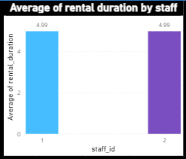**Bar Chart Explanation:**

In the Rental Analysis Dashboard, a bar chart visualizes the average rental duration by staff member. Each bar in the chart represents a staff member (Staff ID 1 and Staff ID 2), and the height of the bar corresponds to the average rental duration in days. In this case, both Staff ID 1 and Staff ID 2 have the same average rental duration, which is approximately 4.99 days.

**Observations and Findings:**

* The bar chart shows that both Staff ID 1 and Staff ID 2 have nearly identical average rental durations, indicating consistent performance in handling rentals in terms of rental duration.
* The average rental duration of approximately 4.99 days suggests that, on average, DVDs rented by customers are kept for about 5 days before being returned. This information can be valuable for inventory management and predicting DVD availability.

**Implications:**

**1. Staff Allocation:** Since both staff members exhibit similar performance, there is an opportunity for optimized staff allocation. We can redistribute staff to address peak rental hours, enhancing customer service during busy periods.

**2. Training Programs:** Identifying consistent performance can guide the development of standardized training programs to ensure uniform service quality across all staff members.

**3. Performance Metrics:** The uniformity in rental duration may prompt the establishment of refined performance metrics and targets for staff members to maintain high-quality service.

**4. Customer Experience:** Consistent rental durations indicate a consistent customer experience, which can contribute to higher customer satisfaction and loyalty.

This analysis provides insights into staff performance and customer behaviour regarding rental durations, enabling the Sakila DVD Rental Store to make informed decisions and enhance customer service.

**PS-10: What is the distribution of customers across different cities?**

**Objective/Need for Analysis:**

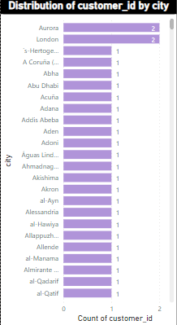The objective of this analysis is to understand the distribution of customers across different cities in the Sakila DVD Rental Store Database (2005-2006). This information provides insights into the geographical customer distribution, highlighting cities with a higher concentration of customers. By visualizing this data, we can identify trends and patterns that may impact business decisions.

**Bar Chart Explanation:**

The clustered bar chart in the Rental Analysis Dashboard illustrates the distribution of customers by city. Each bar represents a city, and the height of the bar indicates the number of customers in that city. Two cities, Aurora and London, stand out with two customers each, while all other cities have only one customer. In total, there are 603 cities and 599 customers in the database.

**Observations and Findings:**

**1. Aurora and London Stand Out:** Aurora and London are the only cities in the database with two customers each, suggesting a potential focus area for marketing efforts or additional services.

**2. Most Cities Have Single Customers:** The majority of cities, 601 out of 603, have just one customer each. This indicates a widespread but dispersed customer base across various locations.

**3. Geographical Diversity:** The data showcases the geographical diversity of customers, emphasizing the need for effective inventory management and distribution strategies to serve a wide range of locations.

**Implications:**

**1. Targeted Marketing**: Given the higher customer concentration in Aurora and London, consider targeted marketing campaigns or promotions to further engage and retain customers in these cities.

**2. Inventory Allocation:** Distribute rental inventory strategically to cater to the dispersed customer base in numerous cities, ensuring that popular films are available to all.

**3. Customer Expansion:** Explore opportunities to expand the customer base in cities with only one customer, potentially through local marketing initiatives or partnerships.

**4. Customer Retention:** Focus on customer retention strategies in cities with multiple customers, as these cities may represent key revenue streams for the business.

This analysis provides valuable insights into the geographical distribution of customers, enabling data-driven decisions to enhance customer engagement, inventory management, and business expansion strategies in the Sakila DVD Rental Store.

**PS-11: How does the rental revenue vary by country?**

**Objective/Need for Analysis:**

The objective of this Rental Analysis is to assess how rental revenue varies by country within the Sakila DVD Rental Store Database (2005-2006). The analysis aims to identify countries contributing significantly to rental revenue, offering insights into revenue distribution and potential business strategies.

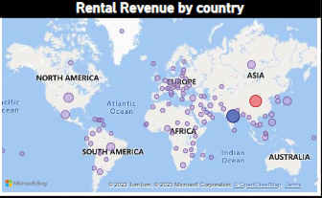**Map Explanation:**

In the Rental Analysis dashboard, a clustered map visualization is employed to visualize the distribution of rental revenue by country. Each country is represented by a bubble, with bubble size proportional to its rental revenue. The colour scheme distinguishes countries, with India displayed as dark blue and China as pink.

**Observations and Findings:**

**1. High Rental Revenue Concentration:** India and China emerge as the top contributors to rental revenue, with India generating $6,628.27 and China contributing $5,798.73. This concentration indicates that a significant portion of rental revenue is derived from these countries.

**2. Global Distribution:** While India and China dominate, the presence of bubbles across various regions suggests a global customer base. This diversity showcases the international reach of the Sakila DVD Rental Store.

**3. Revenue Patterns:** Smaller bubbles represent countries with comparatively lower rental revenue. Analysing these countries can reveal opportunities for growth and potential markets for targeted marketing and expansion.

**4. Data-Driven Insights:** The map visualization enables data-driven decision-making, helping the business allocate resources strategically, refine marketing efforts, and consider tailored services based on regional revenue trends.

**Implications:**

**1. Strategic Focus:** Given the substantial revenue from India and China, the company may consider focusing resources and marketing campaigns on these markets to further capitalize on their potential.

**2. Market Expansion:** Exploring countries with smaller bubbles can guide the company in expanding its services to untapped markets, potentially increasing overall rental revenue.

**3. Customer Segmentation:** Understanding the preferences and behaviours of customers in high-revenue countries versus others can aid in customer segmentation and targeted marketing strategies.

This concise explanation captures the key elements of the Rental Analysis, from its objective and visualization to observations and implications, suitable for documentation in a Word document or a report.

**PS-12: Which locations have the highest and lowest customer ratings?**

Note: Due to the absence of direct customer rating information in the Sakila DVD Rental Store Database (2005-2006), this analysis focuses on customer behaviour based on total payments (total sales revenue) as a proxy for customer ratings. While this approach provides valuable insights, it's essential to acknowledge that direct customer ratings are not available in the dataset, which may limit the depth of the analysis.

**Objective/Need for Analysis:**

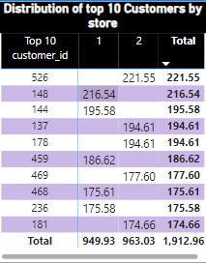The objective of this analysis is to understand customer behaviour and identify which store locations have the highest and lowest customer ratings, using total payments as a proxy. By analysing the distribution of the top 10 customers by total payments across store locations, we aim to gain insights into the revenue contributions of customers and stores within the Sakila DVD Rental Store Database.

**Matrix Explanation:**

In the customer analysis dashboard, a matrix visualization has been used to present the distribution of the top 10 customers by total payments, segmented by store locations (store_id). The matrix provides a summary of the top customers in terms of their total payments, their respective store locations, and the total payments contributed by each store.

**Observation and Findings:**

**1. Top Customers:** The analysis reveals that the top 10 customers, based on total payments, have made significant contributions to the revenue. The highest-paying customer (customer_id 526) has made total payments of 221.55, while the 10th highest-paying customer has made payments of 174.66.

**2. Store Distribution:** Among the top 10 customers, there is an even distribution between two store locations (store_id 1 and store_id 2), with five customers from each store. This suggests that both stores have a set of high-value customers.

**3. Total Payments:** The total payments made by these top 10 customers amount to 1912.96, emphasizing their substantial impact on revenue. This observation highlights the importance of retaining and satisfying these valuable customers.

**Implications:**

**1. Customer Retention:** Identifying and retaining high-value customers is crucial for sustaining revenue. Stores should focus on delivering excellent customer service and personalized experiences to maintain the loyalty of these top customers.

**2. Store Performance:** Store_id 1 and store_id 2 both have a significant share of high-value customers. Store managers should analyse the preferences and rental behaviours of these customers to optimize store performance further.

**3. Revenue Optimization:** Stores can benefit from leveraging insights gained from these top customers to optimize pricing strategies, promotions, and film selections to attract and retain valuable clientele.

This analysis provides valuable insights into customer behaviour based on total payments and offers actionable recommendations for enhancing customer relationships and optimizing revenue for the Sakila DVD Rental Store Database (2005-2006).

**PS-13: What is the distribution of films by language?**

**Objective/Need for Analysis:**

The objective of this analysis is to understand the distribution of films by language in the Sakila DVD Rental Store Database. Although the database encompasses six languages, we observed that all 1000 films in the database are in English. The need for this analysis is to highlight the dominance of English language films and assess if diversification in language offerings could potentially impact customer engagement and rental patterns.

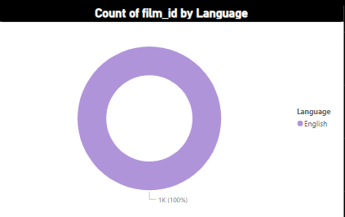**Donut Chart Explanation:**

A donut chart was chosen as the visualization tool to represent this analysis. In the chart, each language category is represented as a segment of the donut, with English as the sole language having a 100% share. The absence of any segments other than English visually conveys that all films in the database are in the English language.

**Observation and Findings:**

* The donut chart clearly illustrates that all films in the Sakila DVD Rental Store Database are in the English language.
* The absence of films in other languages suggests a lack of diversity in the language offerings, which could potentially limit the market reach to non-English-speaking customers.

**Implications:**

**1. Market Expansion Opportunity**: Diversifying the film collection to include movies in languages such as Italian, Japanese, Mandarin, French, and German could open up new markets and attract a broader customer base.

**2. Enhanced Customer Engagement:** Offering films in multiple languages may lead to increased customer engagement and rental frequency, catering to a more diverse audience.

**3. Competitive Advantage**: Distinguishing the store by offering a wider range of language options can create a competitive advantage in the DVD rental market.

**4. Revenue Potential:** Expanding language offerings may lead to increased rentals, potentially boosting revenue and profitability.

This concise explanation outlines the objective, visualization choice, observation, and implications of the film and language analysis in the Sakila DVD Rental Store Database.

**PS-14: Which film categories have the highest rental rates?**

**Objective/Need for Analysis:**

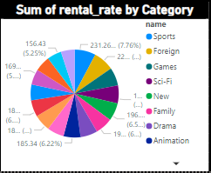The objective of this analysis is to determine which film categories generate the highest rental rates. By understanding customer preferences in terms of film categories, the Sakila DVD Rental Store can make informed decisions about inventory management, marketing strategies, and overall business optimization.

**Pie Chart Explanation:**

* A pie chart was used to visually represent the distribution of rental rates across 16 film categories.
* Each slice of the pie chart represents a film category, and the size of each slice corresponds to the percentage of the total rental rate it contributes.

**Observations and Findings:**

* The "Sports" category stands out with the highest rental rate of $231.26, accounting for 7.76% of the total rental revenue.
* Following closely is the "Foreign" category with a rental rate of $226.27, contributing 7.59%.
* The "Games" category also makes a notable impact, generating a rental rate of $198.39, equivalent to 6.66%.
* In contrast, the "Music" category records the lowest rental rate at $150.49, representing 5.05% of the total rental revenue.

**Implications:**

**1. Inventory Focus:** The analysis suggests that the store should prioritize stocking films in the "Sports," "Foreign," and "Games" categories due to their higher rental rates. This can help optimize inventory management and meet customer demand more effectively.

**2. Marketing Strategy:** The store can tailor marketing campaigns to promote films in the popular categories such as "Sports" and "Foreign" to attract more customers and increase rental revenue.

**3. Pricing Strategy:** Consider adjusting rental pricing strategies for films in high-demand categories while exploring promotions or discounts for categories with lower rental rates like "Music."

**4. Customer Engagement:** Engaging customers with promotions, recommendations, or events related to popular film categories can enhance customer loyalty and retention, further boosting rental revenue.

This analysis provides actionable insights that can assist the Sakila DVD Rental Store in making strategic decisions to maximize rental revenue and enhance customer satisfaction.

**PS-15: How does the average rental duration vary by film category?**

**Objective or Need for Analysis:**

The objective of this analysis is to understand how the average rental duration varies across different film categories in the Sakila DVD Rental Store Database. By examining this variation, we aim to identify potential trends or patterns that can inform inventory management, marketing strategies, and customer preferences. This analysis is essential for optimizing film category selection and ensuring that the store caters effectively to customer demands.

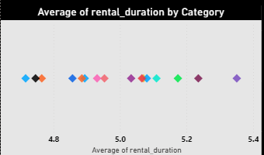**Scatter Plot Explanation:**

We employed a scatter plot to visualize the relationship between film categories and their respective average rental durations. Each point on the scatter plot represents a film category, with the x-axis indicating the film category and the y-axis representing the average rental duration in days.

**Observations and Findings:**

**1. Category Averages:** The analysis revealed distinct variations in average rental durations among film categories. Notably, the "Sports" category has the shortest average rental duration at 4.72 days, followed closely by the "New" category at 4.75 days.

**2. Longer Rental Durations:** Conversely, film categories like "Travel" and "Music" exhibit notably longer average rental durations, with "Travel" leading at 5.35 days, followed closely by "Music" at 5.24 days.

**3. Compact Grouping:** The scatter plot demonstrates that most film categories cluster closely in terms of average rental duration, indicating similar customer preferences and rental behaviours across several genres.

**Implications:**

**1. Inventory Management:** Understanding the variance in rental durations can guide inventory management decisions. For instance, categories with shorter rental durations may require higher stocking levels to meet demand, while those with longer durations may benefit from targeted promotions to boost rentals.

**2. Marketing Strategies:** Tailoring marketing strategies to promote films with shorter durations during peak rental periods and highlighting films with longer durations for extended viewing can enhance customer engagement and satisfaction.

**3. Customer Insights:** This analysis provides insights into customer preferences by film category, enabling the creation of customer segments based on rental behaviours, which can further refine marketing and promotional efforts.

In summary, the analysis of film category and rental duration reveals valuable insights into customer preferences and behaviours, facilitating more effective inventory management and marketing strategies. These findings can positively impact customer satisfaction and store profitability.

**POWER BI DASHBOARD LAYOUT**

